**Positioning Analysis**

Adrian Vasquez, California state university fullerton.edu

Copyright (c) 2024, DecisionPro Inc.

**Table of Contents**

* [**Positioning options**](https://app.enginius.biz/)
  + [Options selected](https://app.enginius.biz/)
  + [Data description](https://app.enginius.biz/)
* [**Dimensions**](https://app.enginius.biz/)
  + [Number of dimensions retained](https://app.enginius.biz/)
  + [Variance explained](https://app.enginius.biz/)
  + [Cumulative variance explained](https://app.enginius.biz/)
* [**Objects**](https://app.enginius.biz/)
  + [Interpretation](https://app.enginius.biz/)
  + [Dimensions I-II](https://app.enginius.biz/)
  + [Coordinates](https://app.enginius.biz/)
* [**Attributes**](https://app.enginius.biz/)
  + [Interpretation](https://app.enginius.biz/)
  + [Dimensions I-II](https://app.enginius.biz/)
  + [Coordinates](https://app.enginius.biz/)
  + [Summary](https://app.enginius.biz/)
* [**Preferences**](https://app.enginius.biz/)
  + [Dimensions I-II](https://app.enginius.biz/)
  + [Preference data](https://app.enginius.biz/)
* [**Market shares**](https://app.enginius.biz/)
  + [Introduction](https://app.enginius.biz/)
  + [Dimension I-II](https://app.enginius.biz/)
* [**Perceptual data**](https://app.enginius.biz/)
  + [Perceptual data](https://app.enginius.biz/)

**Positioning options**

**Options selected**

|  |  |  |
| --- | --- | --- |
|  | **Option** | **Selection** |
|  | Include preferences | Yes |
|  | Number of dimensions | Automatic |
|  | Focal brand | OfficeStar |
|  | Show segments of preferences | No |
|  | Number of segments | Automatic |
|  | Decision rule | First-Choice |
|  | Current market shares | No |
|  | Date and time | 2024-10-18 07:49:51 UTC |

**Options selected**.

**Options selected**.

**Data description**

|  |  |  |  |  |
| --- | --- | --- | --- | --- |
|  | **Data** | **Number of Rows** | **Number of columns** | **Column names** |
| **1** | Perceptual data | 5 | 5 | C0, OfficeStar, Paper and Co, Office Equipment, Supermarket |
| **2** | Preference data | 24 | 5 | C0, OfficeStar, Paper and Co, Office Equipment, Supermarket |

**Data description**.

**Data description**.

**Dimensions**

**Number of dimensions retained**

The first 2 dimensions of the positioning map explain 97.7% of the variance in the data.

Consequently, only the first 2 dimensions will be displayed.

|  |  |  |
| --- | --- | --- |
|  | **Variance explained** | **Cumulative variance** |
| **Dimension 1** | 66.9% | 66.9% |
| **Dimension 2** | 30.8% | 97.7% |
| **Dimension 3** | 2.3% | 100.0% |
| **Dimension 4** | 0.0% | 100.0% |

**Variance explained**. Variance and cumulated variance explained, by dimension.

**Variance explained**. Variance and cumulated variance explained, by dimension.

**Variance explained**

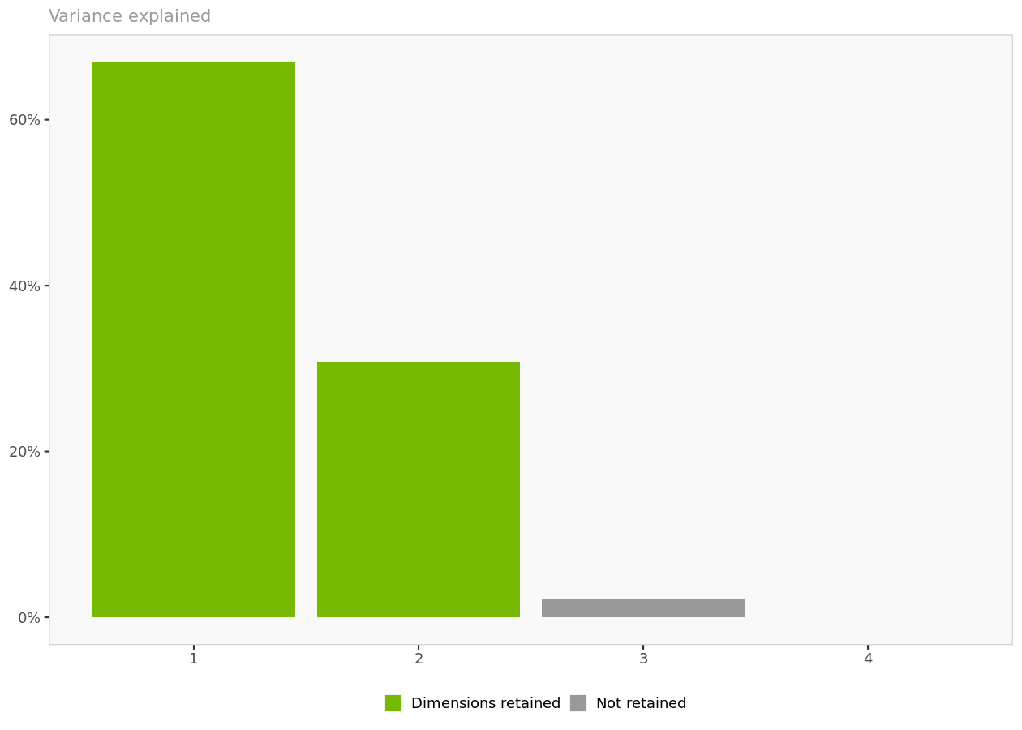

**Variance explained**. Each additional dimension captures a decreasing portion of the variance found in the original data.

**Variance explained**. Each additional dimension captures a decreasing portion of the variance found in the original data.

**Cumulative variance explained**

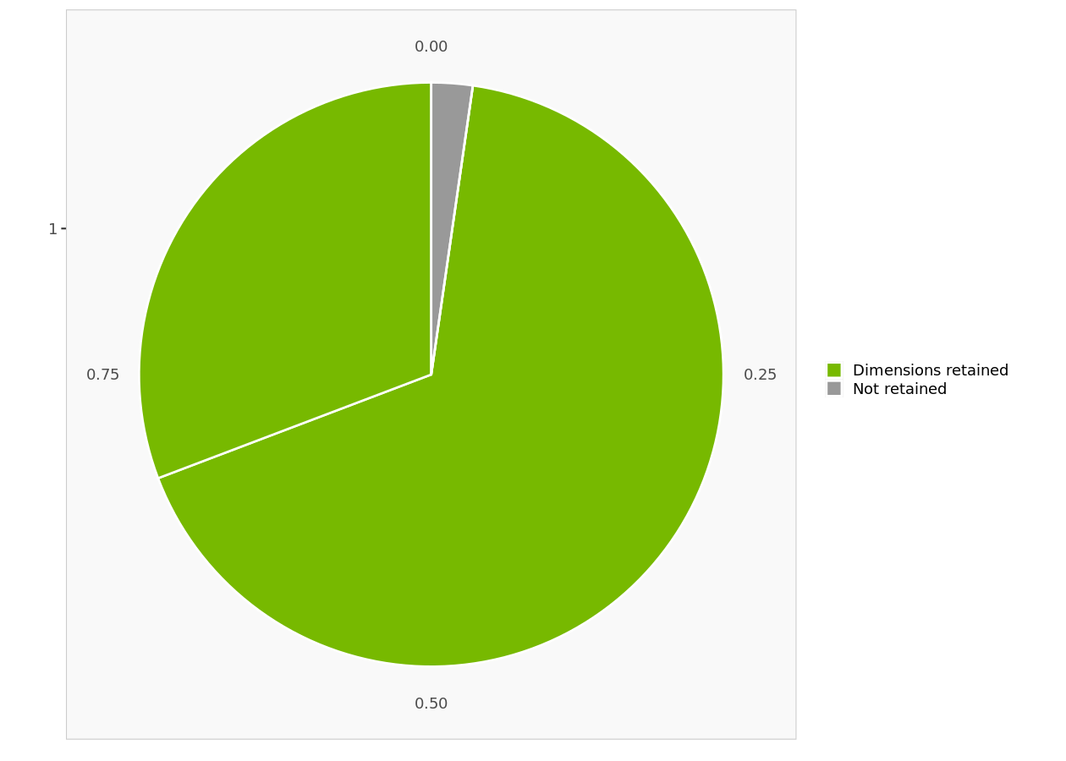

**Cumulative variance explained**. The first 2 dimensions account for 97.7 % of the variance in the data.

**Cumulative variance explained**. The first 2 dimensions account for 97.7 % of the variance in the data.

**Objects**

**Interpretation**

In this section, only the objects (e.g., brands) are displayed on the perceptual map.

In interpreting the map, remember that the closer two objects are, the more similar they are perceived to be, that is, the more similar they rate on the underlying attributes.

**Dimensions I-II**

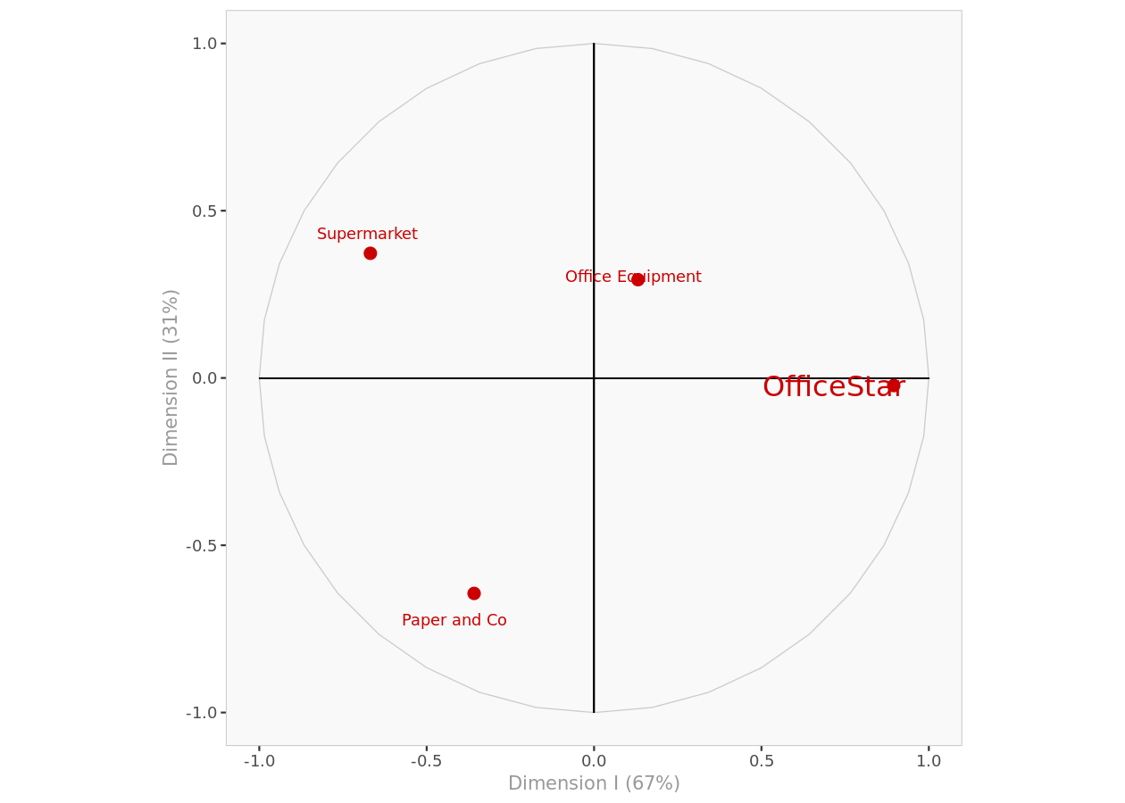

**Objects I-II**. Object position on the first and second dimensions of the perceptual map.

**Objects I-II**. Object position on the first and second dimensions of the perceptual map.

**Coordinates**

|  |  |  |
| --- | --- | --- |
|  | **Dimension I** | **Dimension II** |
| **OfficeStar** | 0.895 | -0.023 |
| **Paper and Co** | -0.358 | -0.644 |
| **Office Equipment** | 0.131 | 0.294 |
| **Supermarket** | -0.668 | 0.373 |

**Object coordinates**. Displays the coordinates of all the objects in every dimension.

**Object coordinates**. Displays the coordinates of all the objects in every dimension.

**Attributes**

**Interpretation**

In interpreting the direction of the attributes, remember that:

* Two attributes that go in the same direction are positively correlated, that is, an object rated high on one attribute will usually be rated high on the other.
* Two attributes that are perpendicular to one another are uncorrelated.
* Two attributes that go in opposite directions are negatively correlated, that is, an object rated high on one attribute will often rate low on the other, and vice-versa.

In interpreting the length of the vector representing the attributes:

* The longer the attribute vector, the better that attribute is captured by the two dimensions displayed.
* If an attribute appears very close to the origin when looking at dimensions I and II, it could be longer and be better captured by dimension III.

**Dimensions I-II**

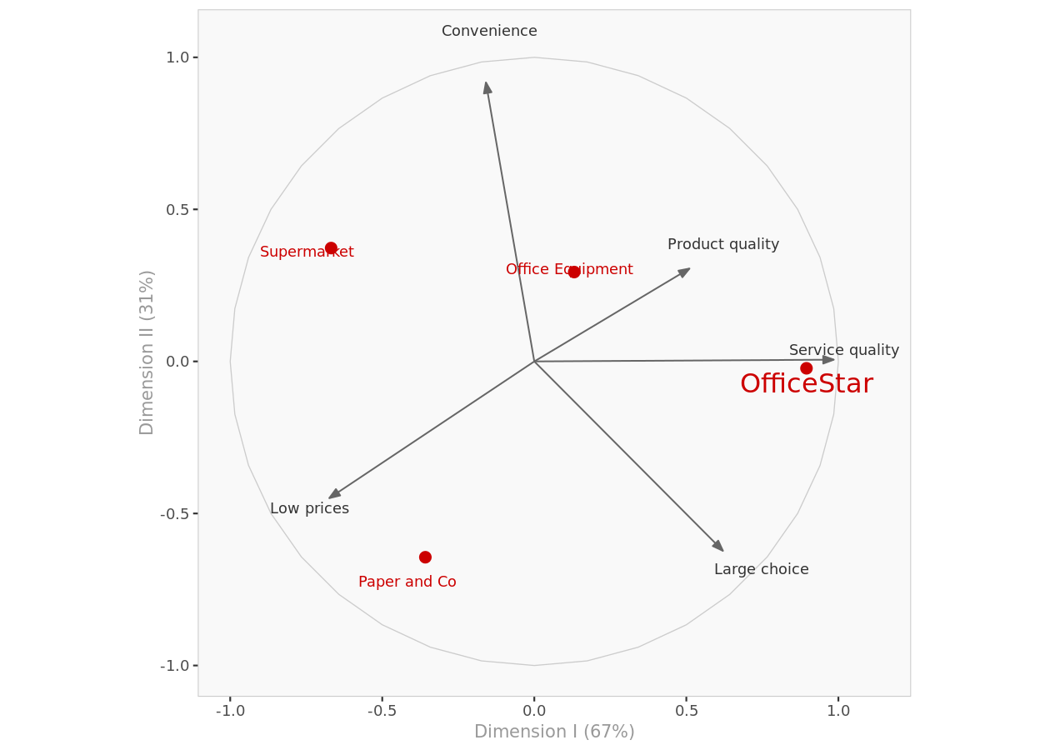

**Attributes I-II**. Objects and attributes on the first and second dimensions of the perceptual map.

**Attributes I-II**. Objects and attributes on the first and second dimensions of the perceptual map.

**Coordinates**

|  |  |  |
| --- | --- | --- |
|  | **Dimension I** | **Dimension II** |
| **Large choice** | 0.620 | -0.623 |
| **Low prices** | -0.674 | -0.450 |
| **Service quality** | 0.985 | 0.006 |
| **Product quality** | 0.510 | 0.305 |
| **Convenience** | -0.159 | 0.917 |

**Attributes coordinates**. Displays the coordinates of all the attributes in every dimension.

**Attributes coordinates**. Displays the coordinates of all the attributes in every dimension.

**Summary**

|  |  |  |
| --- | --- | --- |
|  | **Dimension I** | **Dimension II** |
| **1** | Service quality | Convenience |

**Dimension interpretation**. Displays the names of the attributes most aligned with each dimension.

**Dimension interpretation**. Displays the names of the attributes most aligned with each dimension.

|  |  |  |  |
| --- | --- | --- | --- |
|  | **Dimension I** | **Dimension II** | **Dimension III** |
| **Large choice** | 0.1672 | -0.1678 | 0.1284 |
| **Low prices** | -0.1836 | -0.1224 | -0.1595 |
| **Service quality** | 0.2035 | 0.0012 | 0.0358 |
| **Product quality** | 0.1822 | 0.1090 | -0.2869 |
| **Convenience** | -0.0502 | 0.2893 | 0.1150 |

**Factor loadings (excerpt)**. Displays the factor loadings of attributes.

**Factor loadings**. Displays the factor loadings of attributes.

|  |  |  |
| --- | --- | --- |
|  | **Mean** | **Stdev** |
| **Large choice** | 3.950 | 1.2234 |
| **Low prices** | 3.325 | 1.1558 |
| **Service quality** | 2.850 | 1.0472 |
| **Product quality** | 3.075 | 0.4646 |
| **Convenience** | 3.475 | 1.7366 |

**Mean and standard deviation (excerpt)**. Displays the means and standard deviations of the attributes.

**Mean and standard deviation**. Displays the means and standard deviations of the attributes.

**Preferences**

**Dimensions I-II**

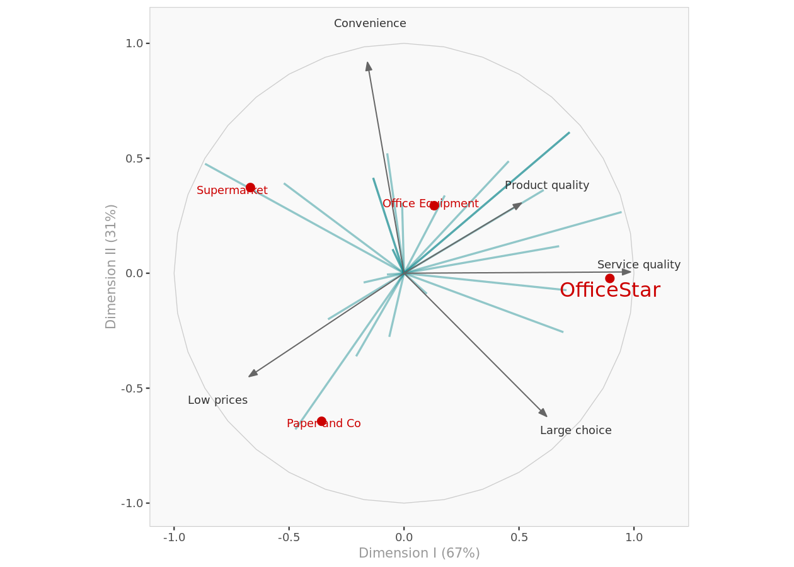

**Perceptual Map I-II**. Complete perceptual map with objects, attributes and preferences on the first and second dimensions.

**Perceptual Map I-II**. Complete perceptual map with objects, attributes and preferences on the first and second dimensions.

**Preference data**

|  |  |
| --- | --- |
|  | **Average preference** |
| **OfficeStar** | 3.46 |
| **Supermarket** | 3.42 |
| **Office Equipment** | 3.21 |
| **Paper and Co** | 2.71 |

**Average brand preference**. For each brand, displays its average preference value in decreasing order.

**Average brand preference**. For each brand, displays its average preference value in decreasing order.

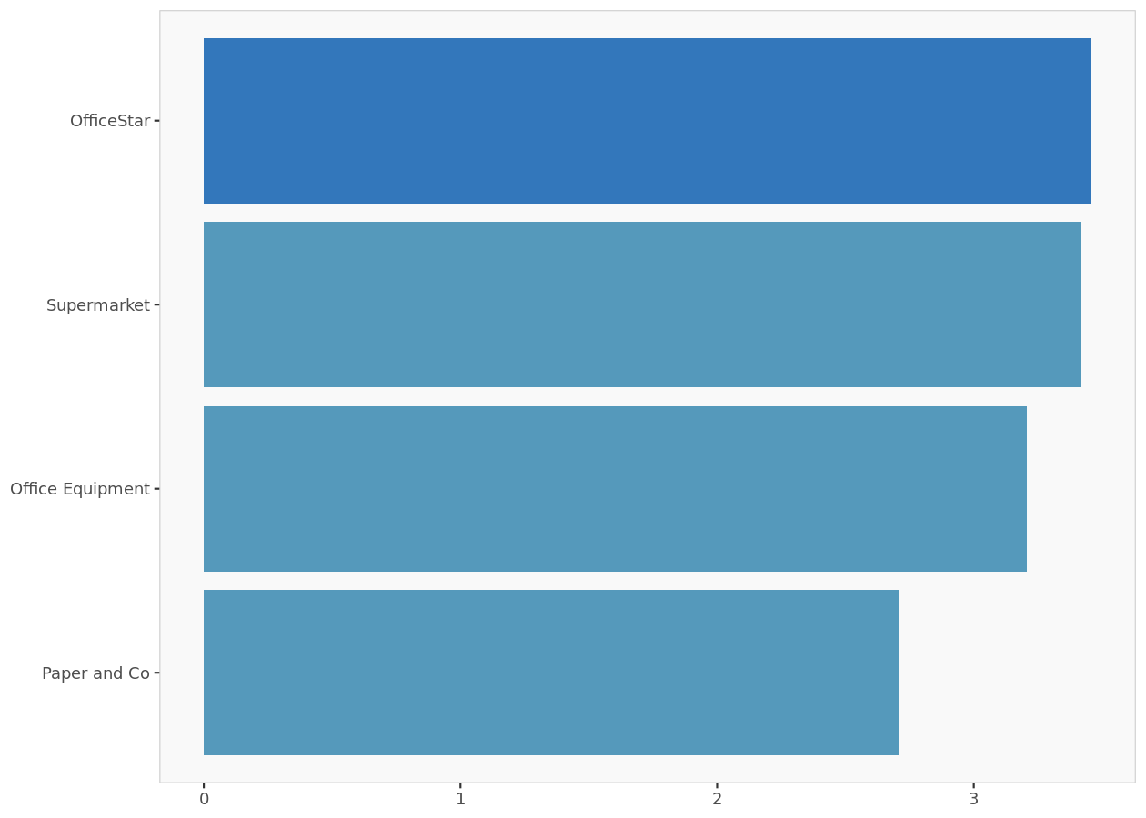

**Average preferences histogram**. For each brand, displays its average preference value.

**Average preferences histogram**. For each brand, displays its average preference value.

|  |  |  |  |
| --- | --- | --- | --- |
|  | **Dimension I** | **Dimension II** | **Dimension III** |
| **Lori** | 0.099 | -0.089 | -0.991 |
| **Mary** | -0.176 | -0.040 | -0.984 |
| **Radjeep** | -0.523 | 0.391 | -0.757 |
| **Antoine** | -0.073 | 0.522 | -0.850 |
| **Yoshi** | -0.134 | 0.415 | -0.900 |
| **Hubert** | 0.707 | -0.074 | 0.704 |
| **Michael** | 0.720 | 0.613 | -0.324 |
| **Elisabeth** | -0.050 | 0.105 | 0.993 |
| **Mike** | 0.607 | 0.362 | -0.707 |
| **Hal** | -0.208 | -0.361 | -0.909 |

**Customer preferences (excerpt)**. Displays the coordinates of customer preferences in every dimension.

**Customer preferences**. Displays the coordinates of customer preferences in every dimension.

**Market shares**

**Introduction**

The following charts display simulations of the market shares a new product would achieve, depending on its position on the perceptual maps.

When two dimensions are displayed (e.g., Dimensions I and II), the new product is assumed to be at the center of the third dimension (e.g., Dimension III = 0).

These computations assume that all the other existing objects (i.e., products) will remain in the market, in their respective positions, and compete with the new entrant.

Market shares are estimated based on stated customers' preferences and the first-choice-rule.

**Dimension I-II**

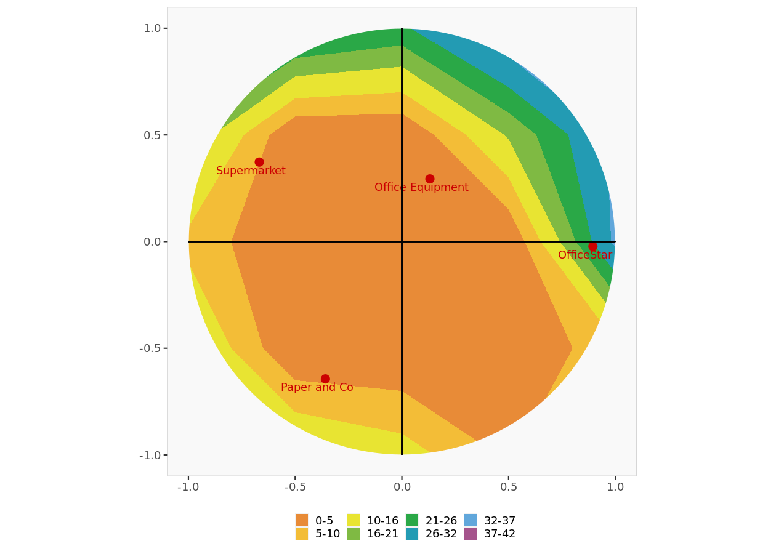

**Market shares Dimension I-II**. Objects positions along with market shares

**Market shares Dimension I-II**. Objects positions along with market shares

|  |  |  |  |
| --- | --- | --- | --- |
|  | **Intercept** | **Dimension I** | **Dimension II** |
| **1** | 3.00 | 0.548 | -0.494 |
| **2** | 3.50 | -1.310 | -0.300 |
| **3** | 3.25 | -1.602 | 1.199 |
| **4** | 3.00 | -0.445 | 3.175 |
| **5** | 3.25 | -0.702 | 2.169 |
| **6** | 2.50 | 1.859 | -0.194 |
| **7** | 3.50 | 1.636 | 1.394 |
| **8** | 3.25 | -0.454 | 0.953 |
| **9** | 2.75 | 2.279 | 1.358 |
| **10** | 3.50 | -1.088 | -1.888 |

**Preference beta values (excerpt)**.

**Preference beta values**.

|  |  |  |
| --- | --- | --- |
|  | **Parameter** | **Value** |
| **1** | Rule | First-choice |
| **2** | alpha | none |

**Market share parameter table**.

**Market share parameter table**.

|  |  |  |  |  |
| --- | --- | --- | --- | --- |
|  | **OfficeStar** | **Paper and Co** | **Office Equipment** | **Supermarket** |
| **Lori** | 4 | 3 | 2 | 3 |
| **Mary** | 3 | 4 | 2 | 5 |
| **Radjeep** | 2 | 3 | 3 | 5 |
| **Antoine** | 3 | 1 | 3 | 5 |
| **Yoshi** | 3 | 2 | 3 | 5 |
| **Hubert** | 4 | 2 | 3 | 1 |
| **Michael** | 5 | 2 | 4 | 3 |
| **Elisabeth** | 2 | 3 | 5 | 3 |
| **Mike** | 5 | 1 | 3 | 2 |
| **Hal** | 3 | 5 | 2 | 4 |

**Actual preference data (excerpt)**.

**Actual preference data**.

**Perceptual data**

**Perceptual data**

|  |  |  |  |  |
| --- | --- | --- | --- | --- |
|  | **OfficeStar** | **Paper and Co** | **Office Equipment** | **Supermarket** |
| **Large choice** | 5.2 | 4.4 | 3.9 | 2.3 |
| **Low prices** | 2.1 | 4.5 | 2.6 | 4.1 |
| **Service quality** | 4.2 | 2.3 | 3.1 | 1.8 |
| **Product quality** | 3.7 | 2.6 | 3.1 | 2.9 |
| **Convenience** | 2.7 | 1.4 | 4.7 | 5.1 |

**Perceptual data overview**. Perception values for each attribute are shown in red if they are significantly (1 standard deviation) less than average perception of all brands. Perception values are shown in green if they are significantly more than average perception of all brands.

**Perceptual data overview**. Perception values for each attribute are shown in red if they are significantly (1 standard deviation) less than average perception of all brands. Perception values are shown in green if they are significantly more than average perception of all brands.

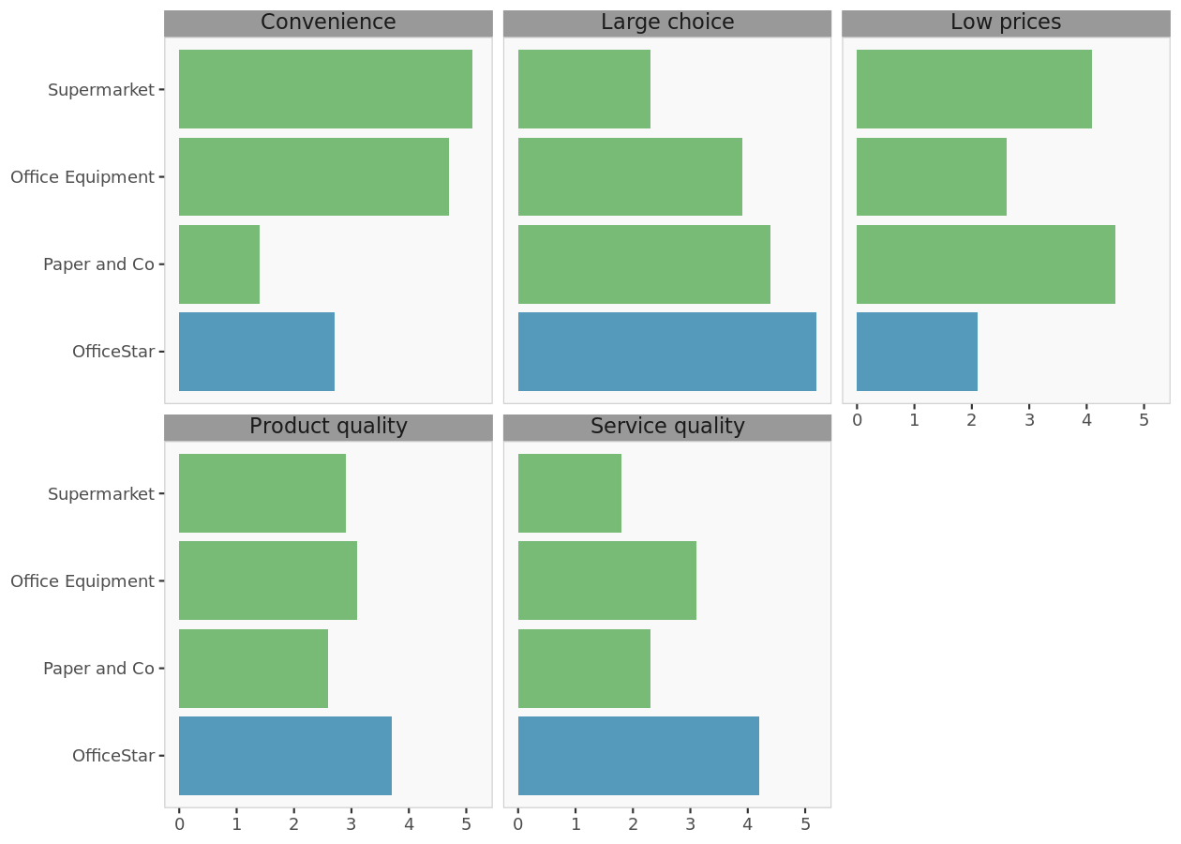

**Attributes histograms**. For each attribute, this chart displays a histogram of brand positions.

**Attributes histograms**. For each attribute, this chart displays a histogram of brand positions.

Copyright (c) 2024, DecisionPro Inc.